1. Consider two datasets (vectors) of student IDs: one represents students who passed a course, and the other represents students who enrolled in the course. Using set operations in R, identify which students did not pass the course but enrolled.

Output:

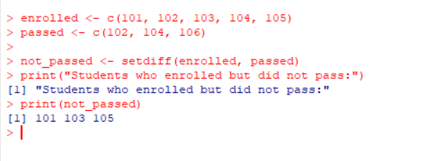

2. Create a 3x3 matrix in R and perform basic operations like addition, subtraction, and multiplication of matrices.

find the determinant of a matrix and check if it is invertible in R?

Write R code to extract specific rows and columns from a matrix.

Access individual elements from a matrix using both numeric and logical indexing?

Output:

(1).

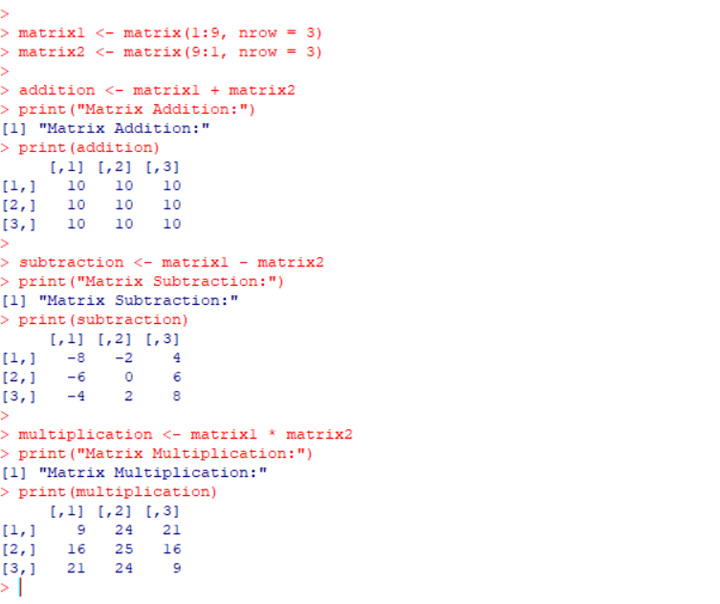

(2).

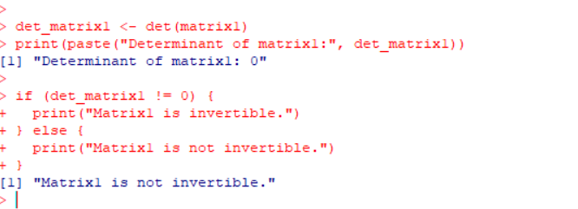

(3).

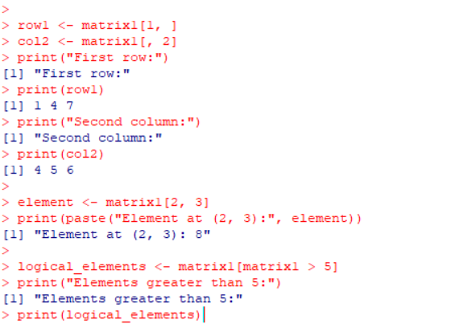

3.Convert a data frame into a matrix? Write R function to find transpose a matrix.

Output:

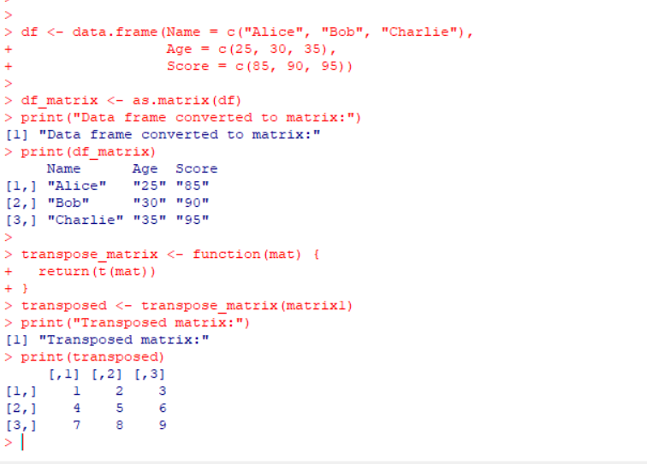

4. Generate a sequence of random numbers from a uniform distribution in R?

Output:

